System Thinking for 911

For the assignment, we belong to the 911 subsystem. To help us explain the requirements of the subsystem and how we should be designing such a system, we had the assistance of an artist illustration. This is so that it will be useful to all the stakeholders as an ideation of the new software develops as it is being designed.

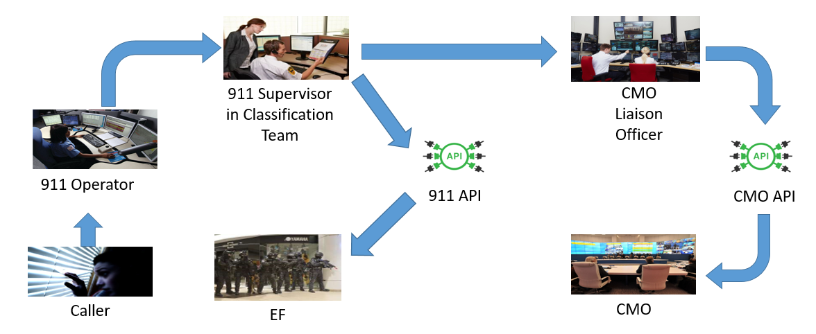

Figure 1. Artist Illustration for 911 subsystem

From the above image, it can be shown that the 911 subsystem consists of different parts such as people, software, hardware, etc. These people include 911 operators, a 911 supervisor in the classification team and a CMO liaison officer. The software may include a web graphical interface as well as a highly secured cloud database whereas the hardware may comprise of computers, monitors, telephones, access passes, etc.

When there is an emergency call received from the caller to the 911 operator, the operator will record all important information pertaining to the call. Subsequently, the operator will store all the information into the database. The 911 supervisor will then classify the class of the incident by accessing the database. After which, should a suspected crisis be found, the CMO liaison officer will be informed to determine the authenticity of the crisis. In the event of a legitimate crisis, the incident report will be forwarded to the Crisis Management Office to handle the situation.

Thus from the above illustration and after applying system thinking, we are able to design the 911 subsystem.